Stratified squamous epithelium

From Wikipedia, the free encyclopedia
Jump to: navigation, search
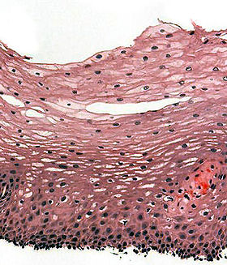
H&E stain of biopsy of normal esophagus showing the stratified squamous cell epithelium
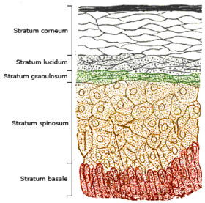
Section of the human skin showing the stratified squamous epithelial surface, referred to as the epidermis. The layer of keratin here is named the stratum corneum
A stratified squamous epithelium consists of squamous (flattened) epithelial cells arranged in layers upon a basement membrane. Only one layer is in contact with the basement membrane; the other layers adhere to one another to maintain structural integrity. Although this epithelium is referred to as squamous, many cells within the layers may not be flattened; this is due to the convention of naming epithelia according to the cell type at the surface.
This type of epithelium is well suited to areas in the body subject to constant abrasion, as the layers can be sequentially sloughed off and replaced before the basement membrane is exposed.
Stratified squamous epithelium is further classified by the presence or absence of keratin at the apical surface. Non-keratinized surfaces must be kept moist by bodily secretions to prevent them drying out and dying, whereas keratinized surfaces are protected from abrasion by keratin and kept hydrated and protected from dehydration by glycolipids produced in the stratum granulosum.
- Non-keratinized stratified squamous epithelium: cornea (see also corneal epithelium), oral cavity, esophagus, rectum, vagina, and the internal portion of the lips
- Keratinized stratified squamous epithelium: skin, tongue (partially keratinized), and the external portion of the lips

[edit] Additional images
